DEPARTMENT OF ELECTRICAL ENGINEERING
Course Descriptive File
1 | Course Title | RF and Microwave Engineering
2 | Course Code | EE433
3 | Credit Hours | 3,1
4 | Pre-requisites
5 | Co-requisites
6 | Semester | VIII
7 | Resource Person | Fatima Qazi
8 | Contact Hours (Theory)
9 | Contact Hours (Lab)
10 | Office Hours | 8am to 4pm
11 | Email | fatimaqazi090@gmail.com
12 | Course Outline as per Scheme of Studies ( SoS)
RF behavior of Passive Components and RF models, Chip components, Distributed Circuit elements, Strip Lines, Microstrip Lines, Coupled Striplines/Coupled microstriplines, Smith Chart, Impedance and Admittance Transformation, Parallel and series Connection, Impedance Matching Networks, Analysis of Single and Multiport Networks using Network Parameters, Microwave Filter Design, Microwave Amplifier design, Mixers and Detectors, Oscillators, Power dividers, Directional Couplers, Circulators, Microwave Systems.

13 | Course Objectives as per SoS
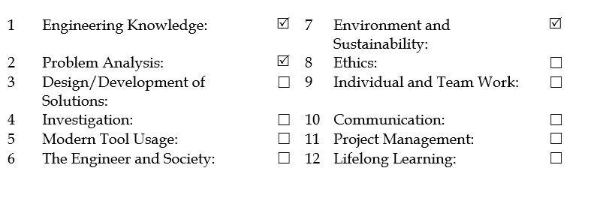
14 | Books
David M. Pozar, "Microwave Engineering", Wiley, 2009.

15 | Course Learning Outcomes (CLOs)
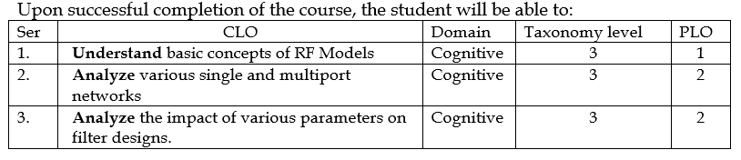

16 | Marks Breakup
Quizzes
Homework/assignments
Midterm exam
Terminal exam (3 hours)
Total (theory) | %
Theory

Lab Assessments
Lab Sessional Exams
( Lab performance + Lab Assessments)

Lab Terminal Exam
(%Viva +%Project+%Paper)

Total (lab) | %
Lab

Final marks | Theory marks * 0.75 + Lab marks * 0.25

17
Week | Topic | CLO | Taxonomy  Level | Specific Outcome | Contact Hours | Assessment
Mid Term  1 | Introduction to Microwave Engineering, Maxwell Equations, Fields in Media and Boundary Conditions, The Helmholtz Equation of Plane Waves in Lossless, Lossy and Good Conductor Medium | CLO1 | C2 |  |  | Assignment 1  Quiz 1
2 | General Plane Wave Solutions, Pointing’s Theorem in Terms of Energy and Power, Plane Wave Reflection from Media Interface (General Medium, Lossless Medium and Good Conductor) | CLO1 | C3
3 | The Lumped Circuit Model for a Transmission Line, The Terminated Lossless Transmission Line, The Smith Chart, The Quarter Wave Transformer | CLO2 | C4
4 | Generator and load Mismatches, Lossy Transmission Lines General Solutions for TEM, TE and TM waves, Attenuation due to Dielectric Loss | CLO2 | C3 |  |  | Assignment 2  Quiz 2
5 | Rectangular Waveguides (TE and TM Mode), Coaxial Line TEM Modes, Strip-line, Micro-stripline, Wave Velocities and Dispersion, Impedance and Equivalent Voltages and Currents | CLO2 | C4
6 | Impedance and Admittance Matrices, The Scattering Matrix (Reciprocal Networks and the Lossless Networks, A Shift in Reference Planes, Generalized Scattering Parameters), The Transmission (ABCD) Matrix | CLO1 | C4
7 | Signal Flow Graphs, Discontinuities and Modal Analysis, Introduction to Impedance Matching and Tuning | CLO1 | C3 |  |  | Assignment 3  Quiz 3
8 | Analytical Solutions of Matching Networks with Lumped Parameters, Smith Chart Solutions, Single Stub Tuning, Double Stub Tuning, The Quarter Wave Transformer | CLO2 | C5
9  Final  Term | Introduction to Microwave Resonator, Series and Parallel Resonance Circuit, Transmission Line Resonator, Rectangular Waveguide Cavities | CLO2 | C4
10 | Basic Properties of Dividers and Couplers, The T Junction Power Divider, Lossless Divider, Resistive Divider, The Wilkinson Power Divider, The Quadrature Hybrid, Coupled Line Directional Couplers, The180⁰ Hybrid
11 | Introduction to Microwave Filters, Filter Design by Insertion Loss Method, Maximally Flat Low Pass Filter Prototype, Equal Ripple Low Pass Filter Prototype, Linear Phase Low Pass Filter Prototypes
12 | Filter Transformations using Impedance and Frequency Scaling, Low Pass to High Pass Filter Transformation, Low Pass to Band Pass and Band Stop Filter Transformation, Filter Implementation, Stepped Impedance Low Pass Filters
13 | Introduction to Active Microwave Circuits, Noise in Microwave System, Detectors and Mixers, Pin Diode Phase Shifters
14 | Design of Microwave Amplifiers and Oscillators, Microwave Field Effect Transistors, Microwave Bipolar Transistors, Gain and Stability
15 | Single Stage Transistors Amplifier Design, Constant Gain Circles and Design for Specified Gain
16 | Introduction to Microwave Systems, System Aspects of Antennas, Basic Types of Antennas, Antenna Pattern Characteristics, Microwave Communication System, The Friis Power Transmission Formula

- Every instructor have his/her plan for course material used for assignments and quizzes, table above is just a guideline.

18 | Course Learning Outcomes (CLOs) and Assessment Plan
CLO  Activity | CLO 1 | CLO2 | CLO3
Quiz 1 | C1, C2
Quiz 2 |  | C3, C4
Quiz 3 |  |  | C3, C4
Assignment 1
Assignment 2
Assignment 3
MID TERM EXAM
Quiz 1
Quiz 2
Quiz 3
Assignment 1
Assignment 2
Assignment 3
FINAL TERM EXAM

*Add columns according to number of course CLO’s for your respective course. Complete as per your planned quiz and assignments for this session.

19 | Course Learning Outcomes (CLOs) and Assessment Plan (LAB)
CLO  Activity | CLO L1 | CLO L2 | CLO L3
Lab 1 | C1, C2
Lab 2 |  | C3, C4
Lab 3 |  |  | C3, C4
Lab 4
Lab 5
Lab 6
Lab 7
Lab 8
Lab 9
Lab 10
Lab 11
Lab 12
Term Project
Session Test
Final Lab paper
Viva

*Add columns according to number of course CLO’s for your respective course. Complete as per your planned quiz and assignments for this session.

20 | Lab Details
Laboratory Resources
- Hardware based
Computer Resources
- Software based
21 |  | Mapping of CLOs to PLOs
PLO  CLOs | PLO1 | PLO2 | PLO3 | PLO4 | PLO5 | PLO6 | PLO7 | PLO8 | PLO9 | PLO10 | PLO11 | PLO12
CLO1 | C1
CLO2 |  |  |  | C4
CLO3 |  |  |  | C4
CLO4 |  | C2
LAB CLO1
LAB CLO2
LAB CLO3

22 | List of Experiment With Objectives as Per OBE Format
Lab Experiment No. | Title and Objectives
1 | Title:  Objectives
2 | Title:  Objectives
3
4
5
6
7
8
9
10
11
12
13
14
15
16

*title and objective to be achieved in every experiments

